In this section, we present two different approaches to estimating savings using Option C:
- Monthly-based data analysis (most common application of Option C).
- Hourly-based data analysis (increasing use with use of smart meters)

I. Monthly-based data case studies

CASE A- Several Measures in a Commercial Mall

1. Situation
This project involves the implementation of a package of various Energy Conservation Measures (ECMs) in a mall:
- Replacement of lighting in different areas
- Various improvements in the HVAC of common spaces
- Set schedule control system
This retrofit is expected to save 27% of the total energy use. The user requires the application of option C, the ESCO who develops the project agrees and the characteristics of the project are favorable to this approach (large expected savings expected and potential existence of interactive effects between ECMs). Table 1 provides monthly data describing the site.

2. M&V Option selected
The M&V plan describes the procedures and uncertainty analysis for the electric savings based on the monthly energy use data. Because the energy efficiency projects affect both the lighting and HVAC systems, and have a high degree of interaction, the measurement boundary for the project was selected as whole building so that all energy using systems in the building were included. Activities and issues addressed in the M&V Plan include the following:
- The plan will be IPMVP-adherent, Option C.
- The electricity supplier meters will be used for calculations during reporting period, as well as for the equations for baseline adjustments. Additional meters are available at the same point of those of the energy supplier, for their use in case of failure.
- The primary influences of the building’s energy use were ambient temperature and occupancy, due to the elevated charge of heating/cooling needs.
- The owner wants to know the energy savings of the project as follows:
  - 5 years of reporting period.
  - Use of “avoided energy/cost” approach.

3. Assumptions
- The range of data in the baseline period is sufficient to capture the behavior of energy use by covering two natural years.
- The data used in the development of baseline energy model are normally distributed and show no autocorrelation (no correlation between monthly use data).
- Building occupancy range is properly covered with the baseline data.

4. Sources of Error

Table 1: Monthly Site Data
Month | Use (kWh) | Days | Occupnacy (Asist./month) | Average Temp (ºC) | RH (%) | Wind speed (m/s) | Solar radiation (MJ/m2) | Eto (mm)
jan-12 | 579.651 | 30 | 1.006.401 | 3,89 | 76,90 | 1,50 | 8,84 | 33,19
feb-12 | 594.073 | 29 | 654.359 | 4,08 | 51,74 | 2,73 | 12,92 | 61,47
mar-12 | 564.725 | 31 | 680.281 | 10,28 | 50,88 | 1,86 | 17,71 | 95,94
apr-12 | 496.578 | 30 | 679.402 | 11,11 | 63,92 | 2,97 | 17,92 | 99,69
may-12 | 572.999 | 31 | 671.193 | 17,94 | 53,77 | 1,77 | 24,66 | 154,58
jun-12 | 614.323 | 30 | 672.679 | 23,17 | 40,79 | 1,85 | 26,73 | 185,75
jul-12 | 687.538 | 31 | 752.889 | 24,09 | 40,15 | 1,45 | 28,89 | 196,71
aug-12 | 684.956 | 31 | 633.692 | 24,89 | 39,58 | 1,59 | 24,00 | 178,89
sep-12 | 560.727 | 30 | 667.995 | 19,61 | 52,87 | 1,46 | 17,21 | 103,80
oct-12 | 504.948 | 31 | 740.113 | 13,88 | 73,32 | 1,14 | 13,06 | 58,07
nov-12 | 537.085 | 30 | 761.291 | 8,98 | 80,53 | 1,13 | 7,11 | 26,55
dec-12 | 636.226 | 31 | 1.016.147 | 5,21 | 83,97 | 1,51 | 5,96 | 23,04
jan-13 | 623.013 | 30 | 972.843 | 4,54 | 79,34 | 2,05 | 7,09 | 27,43
feb-13 | 553.987 | 28 | 624.314 | 5,65 | 69,02 | 2,51 | 10,51 | 45,73
mar-13 | 563.895 | 31 | 737.934 | 8,74 | 75,67 | 2,49 | 11,72 | 60,98
abr-13 | 515.410 | 30 | 654.375 | 11,40 | 65,32 | 2,44 | 19,42 | 96,01
may-13 | 498.257 | 31 | 707.727 | 13,57 | 62,04 | 1,84 | 24,13 | 131,50
jun-13 | 571.834 | 30 | 713.490 | 20,38 | 45,29 | 2,21 | 28,07 | 189,12
jul-13 | 697.448 | 31 | 816.359 | 25,66 | 38,30 | 1,80 | 27,62 | 210,20
aug-13 | 679.146 | 31 | 665.028 | 24,64 | 40,73 | 1,71 | 24,25 | 183,75
sep-13 | 599.502 | 30 | 681.026 | 20,27 | 53,30 | 1,56 | 19,07 | 122,15
oct-13 | 508.782 | 31 | 719.023 | 14,79 | 72,70 | 1,37 | 12,52 | 67,52
nov-13 | 529.013 | 30 | 789.645 | 7,79 | 70,96 | 2,12 | 8,61 | 45,17
dec-13 | 618.030 | 31 | 1.068.260 | 3,68 | 77,80 | 1,64 | 7,57 | 27,99

5. Statistical analysis
The analysis of this case begins by performing an exploratory assessment of each of the variables considered.

Since the total monthly energy consumption clearly depends on the number of days in month, use data were normalized to average consumption per day. Figure 1 shows a marked seasonal component in the series of energy consumption. The average daily consumption also shows very marked cyclical behavior. Important consumption peaks are observed during the months of July and August and during the coldest months December, January and February.

Figure 1: Energy Consumption vs time
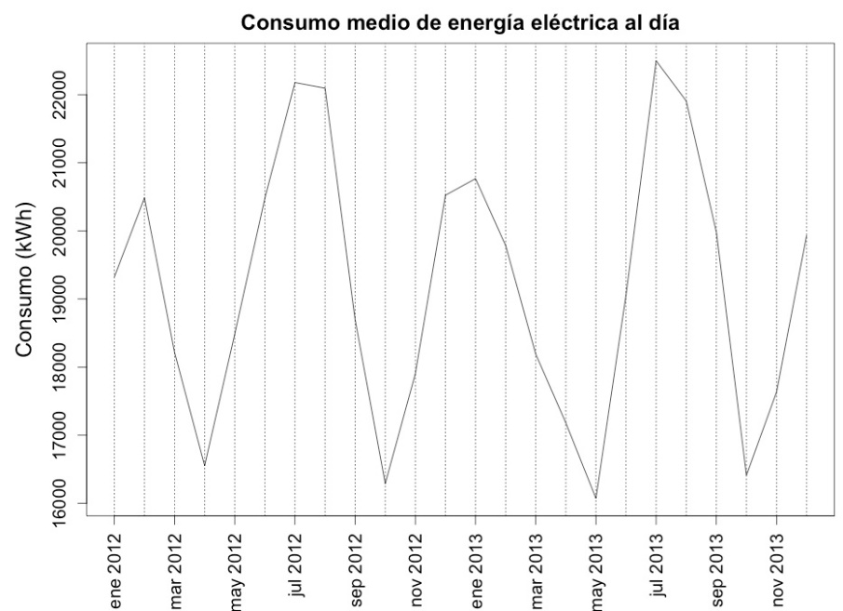

5.1. Progressive Elimination of variables

In this section, we attempt to estimate the best multi-variable linear model.

- Model 1
The model we propose is as follows:
- Dependent Variable: Average daily consumption: kWh (month)/days per month
- Explanatory variables:
  - Days (of the energy period)
  - Occupancy
  - Temperature
  - RH (relative humidity)
  - Windspeed
  - Radiation
  - CWSI
Equation:
$$Energy per day \left(kWh\right)=β_{0}+β_{1}∙days+β_{2}∙occupancy+β_{3}∙temperature+β_{4}∙RH+ β_{5}∙windspeed+ β_{6}∙radiation+ β_{7}∙CWSI+ ε$$

Developing the linear regression analysis using “R” software, we obtain the following results:

Call:
lm(formula = energy.d ~ days + occupancy + temperature + RH + windspeed + radiation + CWSI)

Residuals:
Min 1Q Median 3Q Max
-1978.21 -510.17 -88.52 819.47 1563.69

Coefficients:
Estimate Std. Error t value Pr(>|t|)
(Intercept) 4.406e+04 1.139e+04 3.867 0.00136 **
days -6.159e+02 3.893e+02 -1.582 0.13316
occupancy 6.331e-03 3.564e-03 1.777 0.09465 .
temperature -1.469e+02 1.566e+02 -0.938 0.36204
RH -9.933e+01 4.802e+01 -2.068 0.05517 .
windspeed -6.022e+02 8.651e+02 -0.696 0.49632
radiation -6.761e+02 2.114e+02 -3.198 0.00560 **
CWSI 9.564e+01 4.209e+01 2.272 0.03722 *
---
Signif. codes: 0 ‘***’ 0.001 ‘**’ 0.01 ‘*’ 0.05 ‘.’ 0.1 ‘ ’ 1

Residual standard error: 1041 on 16 degrees of freedom
Multiple R-squared: 0.8042, Adjusted R-squared: 0.7185
F-statistic: 9.388 on 7 and 16 DF, p-value: 0.0001191

- Model 2
Based on model results, windspeed has a p value of 0.49 approximately. P values over 0.05 are considered not statistically significant (in this case, windspeed does not appear to have a significant impact on daily energy use. In this model, drop windspeed from the equation..

Call:
lm(formula = energy.d ~ days + occupancy + temperature + RH + radiation + CWSI)

Residuals:
Min 1Q Median 3Q Max
-2032.16 -508.27 17.18 758.82 1621.13

Coefficients:
Estimate Std. Error t value Pr(>|t|)
(Intercept) 3.994e+04 9.590e+03 4.165 0.000648 ***
days -5.464e+02 3.705e+02 -1.475 0.158547
occupancy 7.827e-03 2.799e-03 2.796 0.012410 *
temperature -6.144e+01 9.568e+01 -0.642 0.529345
RH -1.101e+02 4.476e+01 -2.460 0.024898 *
radiation -6.144e+02 1.890e+02 -3.251 0.004705 **
CWSI 7.783e+01 3.291e+01 2.365 0.030200 *
---
Signif. codes: 0 ‘***’ 0.001 ‘**’ 0.01 ‘*’ 0.05 ‘.’ 0.1 ‘ ’ 1

Residual standard error: 1025 on 17 degrees of freedom
Multiple R-squared: 0.7983, Adjusted R-squared: 0.7271
F-statistic: 11.21 on 6 and 17 DF, p-value: 4.13e-05

- Model 3
Now the less significant variable is temperature with p value of 0.52. We repeat the analysis without temperature.

Call:
lm(formula = energy.d ~ days + occupancy + RH + radiation + CWSI)

Residuals:
Min 1Q Median 3Q Max
-1946.72 -538.50 -51.01 837.79 1526.45

Coefficients:
Estimate Std. Error t value Pr(>|t|)
(Intercept) 4.182e+04 8.983e+03 4.656 0.000197 ***
days -6.330e+02 3.394e+02 -1.865 0.078541 .
occupancy 8.788e-03 2.327e-03 3.777 0.001381 **
RH -1.173e+02 4.263e+01 -2.752 0.013129 *
radiation -5.437e+02 1.511e+02 -3.598 0.002058 **
CWSI 6.230e+01 2.195e+01 2.838 0.010916 *
---
Signif. codes: 0 ‘***’ 0.001 ‘**’ 0.01 ‘*’ 0.05 ‘.’ 0.1 ‘ ’ 1

Residual standard error: 1008 on 18 degrees of freedom
Multiple R-squared: 0.7934, Adjusted R-squared: 0.736
F-statistic: 13.82 on 5 and 18 DF, p-value: 1.244e-05

- Model 4
Now the less significant variable is days.

Call:
lm(formula = energy.d ~ occupancy + RH + radiation + CWSI)

Residuals:
Min 1Q Median 3Q Max
-1906.90 -693.08 -1.44 585.27 2194.03

Coefficients:
Estimate Std. Error t value Pr(>|t|)
(Intercept) 2.612e+04 3.331e+03 7.841 2.26e-07 ***
occupancy 7.493e-03 2.361e-03 3.173 0.00501 **
RH -1.441e+02 4.267e+01 -3.377 0.00317 **
radiation -5.365e+02 1.606e+02 -3.339 0.00345 **
CWSI 5.197e+01 2.259e+01 2.301 0.03290 *
---
Signif. codes: 0 ‘***’ 0.001 ‘**’ 0.01 ‘*’ 0.05 ‘.’ 0.1 ‘ ’ 1

Residual standard error: 1072 on 19 degrees of freedom
Multiple R-squared: 0.7534, Adjusted R-squared: 0.7015
F-statistic: 14.51 on 4 and 19 DF, p-value: 1.365e-05

Now all the variables included are significant (p<0.05), but the model obtained could be improved by further analysis.

5.2. Change Point Model
Since most of the energy consumption occurs due to the demand of heating and cooling, the explanatory variable that focuses our attention in this study is the average temperature of each month.

Another explanatory variable we considered in the study was the occupancy (number of people who have come monthly to the mall). Next figure shows scatterplots of consumption versus average temperature and against the occupancy by day. In these graphs a clearer relationship between consumption and temperature shows than between consumption and occupancy.

Figure2: Energy Vs Temperature and Energy Vs Occupancy

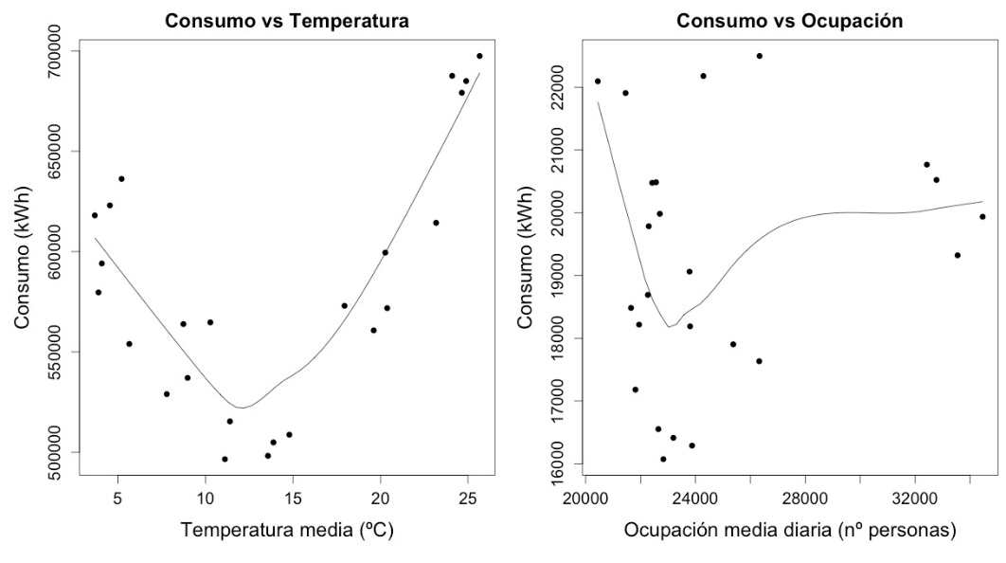

Energy consumption decreases with increasing temperature to 15 ° C, and then increases linearly for temperatures above this value. The value of 15 ° C is therefore a turning point for the linear regression model we propose later.

Another option would be to obtain a model without changing points where we consider a quadratic effect of temperature. Figure 3, shows scatterplots of average energy consumption per day compared to other meteorological variables that measure characteristics such as relative humidity, and wind speed, among other.

The variable less correlated with energy consumption seems to be the wind speed. In other cases, the consumption of energy presents a quadratic relationship with the other meteorological variables considered. This U-shaped pattern, is similar in all three cases because these variables are linearly related (high values of some variables are associated with high values of the other, and vice versa).

The models can not include these variables simultaneously, as would present a problem referred to as multicollinearity. We propose a regression model with a turning point where energy consumption depends on temperature. This model also includes a binary variable that differentiates the coldest months (December, January, February and March).

Figure 5: Energy Use Vs. Meteorological Variables

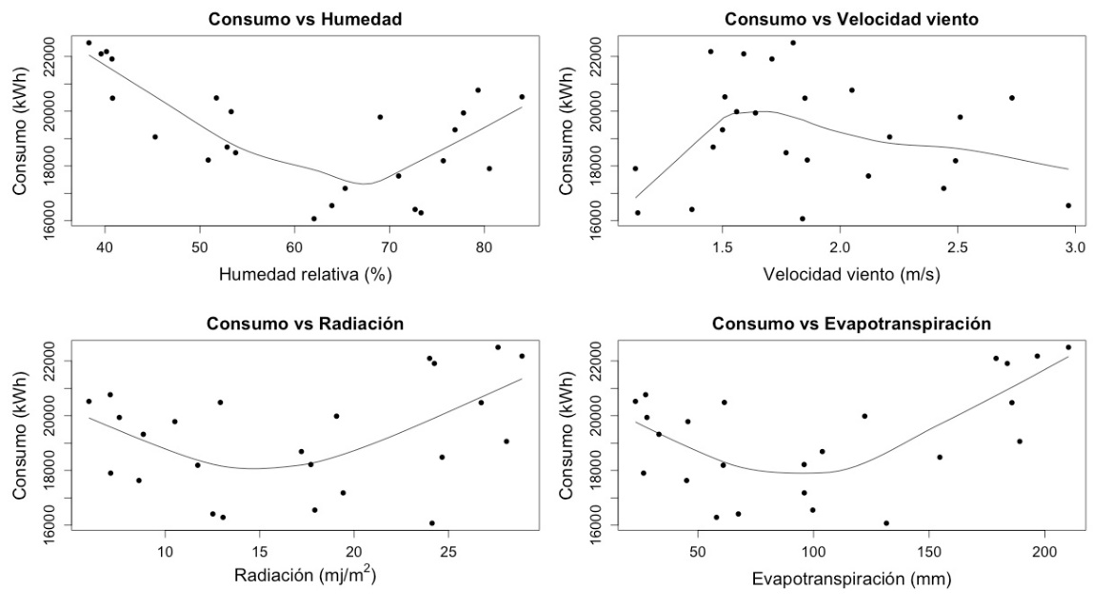

Dependent variable:
- Energy consumption: average daily energy consumption per month (kWh/days·month)
Explanatory variables:
- Temperature: monthly average temperature (ºC)
- D: binary variable. D = 0 for temperatures below 15 ° C and D = 1 otherwise
- Season: binary variable. Season = 0 for the colder months (December, January, February and March), and Season = 1 for the remaining months.

Equation of the proposed model:

$$Average dayly consumption= β_{0}+β_{1}·Temp+β_{3}·D·(Temp-15)+β_{4}·season+ε$$

As shown below, all model parameters are significant (p<0.05). This model features a high degree of goodness of fit: R² = 0.94 (exceeding the IPMVP recommended cutoff of 0.75).

Call:
lm(formula = energy.d ~ temperature + t15 + season)

Residuals:
Min 1Q Median 3Q Max
-836.66 -307.51 -73.14 342.36 784.42

Coefficients:
Estimate Std. Error t value Pr(>|t|)
(Intercept) 21209.72 345.32 61.421 < 2e-16 ***
temperature -270.27 51.62 -5.236 4.01e-05 ***
t15 889.79 76.21 11.676 2.20e-10 ***
season -1130.46 409.79 -2.759 0.0121 *
---
Signif. codes: 0 ‘***’ 0.001 ‘**’ 0.01 ‘*’ 0.05 ‘.’ 0.1 ‘ ’ 1

Residual standard error: 497 on 20 degrees of freedom
Multiple R-squared: 0.9442, Adjusted R-squared: 0.9358
F-statistic: 112.7 on 3 and 20 DF, p-value: 1.06e-12

The estimated model:

$$Daily Use=21.209-270·Temp \left(ºC\right)+889·D*\left(Temp-15\right)-1.130·Season$$

Another estimate worth noting is the CV_{RMSE} or the coefficient of variation of the Root Mean Square Error.
${CV}_{RMSE}=\frac{{SE}_{\hat{Y}}}{\overline{Y}}=\frac{497}{19.193}=0,026$ (IPMVP recommended cut off is 0.2)
The mean value of Y is the average of the daily average energy consumption per month.

This model has passed the basic statistical and IPMVP guidelines. As such, we can use it to predict energy use. The following table presents the predictions for the average electricity consumption. All predictions are based on plugging in the appropriate values in the equation above:

Table 2: Model Predictions
Average temp (ºC) | Type of month | Predicted daily consumption (kWh)
5 | Cold | 19858
10 | Cold | 18507
15 | Warm | 16025
20 | Warm | 19123
25 | Warm | 22220

5.3. Comparison with a quadratic model
Equation of the proposed model:

$$Average daily consumption= β_{0}+β_{1}·Temperature+β_{3}·Temperature^2+ε$$

Call:
lm(formula = energy.d ~ temperature + temperature.2)

Residuals:
Min 1Q Median 3Q Max
-1131.86 -566.54 69.28 532.00 1076.99

Coefficients:
Estimate Std. Error t value Pr(>|t|)
(Intercept) 23908.488 562.993 42.47 < 2e-16 ***
temperature -1040.475 93.883 -11.08 3.11e-10 ***
temperature.2 39.157 3.184 12.30 4.63e-11 ***
---
Signif. codes: 0 ‘***’ 0.001 ‘**’ 0.01 ‘*’ 0.05 ‘.’ 0.1 ‘ ’ 1

Residual standard error: 669.2 on 21 degrees of freedom
Multiple R-squared: 0.8937, Adjusted R-squared: 0.8836
F-statistic: 88.3 on 2 and 21 DF, p-value: 5.991e-11

The residual standard error of the quadratic model is equal to 669.2, and whereas that the standard error of the one point-change model is 497. As such, we elect to use the first model to make the Baseline adjustments during the reporting period (RP).

6. Savings and Uncertainty
- $Model$ proposed

$$Energy Use= 21.209-270·Temp \left(ºC\right)+889·D*\left(Temp-15\right)-1.130·Season$$

With expected savings per year = 62.102 kWh, to calculate the uncertainty we use the following equation:

$$u\left(\%\right)=\frac{t_{α/2}∙\sqrt{{{n∙SE}_{\hat{Y}}}^{2}}}{expected savings for the period}×100$$

So, if we introduce into the equation the previous data, the relative uncertainties of the model are:

$$u\left(\%\right) for 1 year=\frac{1,72∙\sqrt{{12∙497}^{2}}}{62.102}×100=±4,8\%$$

$$u\left(\%\right) for 5 years=\frac{1,72∙\sqrt{{60∙497}^{2}}}{310.510}×100=±2,14\%$$

We can see that in this case the final expected uncertainty of the model proposed is better than the initial goal value (7% for 90% confidence).

6.1 Uncertainty during the Reporting period
Table 3 shows the values for the reporting period (temperature, observed consumption, predicted consumption, savings, and % savings). The model was developed using the baseline period and the applied to the reporting period using actual temperature data and binary designations for season. The difference between observed consumption during RP and predicted (i.e., what it would have been had baseline conditions persisted) consumption, is savings. Overall, the mall used 162,886 kWh when it would have used 226,729 kWh during the RP. As such, the estimated savings are 63,843 kWh or 28% reduction in use (recall, the expectation was for 62,102 kWh of savings. The overall uncertainty for one year is 4.8% (see equation above).

Table 3: Analysis Results
Month | Season | Temperature | Predicted During RP | Observed during RP | Savings | % Savings
Jan-14 | 0 | 7,23 | 19,256 | 13,423 | 5,833 | 30%
Feb-14 | 0 | 6,62 | 19,421 | 14,152 | 5,269 | 27%
Mar-14 | 0 | 9,96 | 18,518 | 13,147 | 5,371 | 29%
Apr-14 | 1 | 14,99 | 16,028 | 11,558 | 4,470 | 28%
May-14 | 1 | 17,17 | 17,370 | 12,832 | 4,538 | 26%
Jun-14 | 1 | 21,52 | 20,064 | 13,998 | 6,066 | 30%
Jul-14 | 1 | 23,38 | 21,217 | 14,980 | 6,237 | 29%
Aug-14 | 1 | 24,08 | 21,650 | 15,741 | 5,909 | 27%
Sep-14 | 1 | 20,36 | 19,346 | 14,556 | 4,790 | 25%
Oct-14 | 1 | 16,11 | 16,713 | 12,453 | 4,260 | 25%
Nov-14 | 1 | 10,37 | 17,277 | 12,206 | 5,071 | 29%
Dec-14 | 0 | 4,96 | 19,869 | 13,840 | 6,029 | 30%
TOTAL |  |  | 226,729 | 162,886 | 63,843 | 28%

II. Hourly data case study

Whole Building using short time interval energy use data

1. Situation
In this example, multiple operational improvements were made in a university chemistry building as part of a retro-commissioning project. The improvements included:
- The constant volume chilled water, hot water, and air distribution systems were converted to variable volume, with the addition of variable frequency drives to fan and pump motors, and implementation of appropriate control algorithms.
- The legacy pneumatic control system was upgraded to a digital system, enabling HVAC systems to implement advanced control strategies, including:
  - Duct static pressure set point reset
  - Supply air temperature set point reset
  - Optimum start
- Over-ventilation in the buildings was reduced
- The T-12 fluorescent lighting systems were replaced with dimmable LED lamps. An advanced lighting controls system was also installed that enabled task lighting, scheduling, and daylight controls.
- Leaky pre-heat coils in air handling units were repaired, eliminating simultaneous heating and cooling.
These improvements were estimated to save 20% of annual electricity consumption. Many months prior to the start of the retro-commissioning project, a time-of-use (TOU) electric meter was installed to measure electric energy use at 15 minute intervals in the building. These measurements were recorded in a database.

This example will demonstrate how regression-based analysis based short-time interval energy use, ambient temperature, and a time-of-week variable may be used in an Option C approach to estimate the electric energy savings and uncertainty for this project.

2. M&V Option selected
The energy efficiency projects affect multiple systems within the building, and there is a high degree of interaction, therefore IPMVP Option C Whole Building was selected for quantifying the electric energy savings for this project. Six months of baseline period energy use data, measured at 15-minute intervals were available, and a year of savings was estimated under normalized conditions (normalized savings) after six months of post-installation energy use data collected.

M&V Plan requirements and other considerations in selecting Option C include:

- Non-revenue grade whole-building electric meters were installed and calibrated eight months in advance of the comprehensive upgrade project, providing electric energy use data at 15 minute intervals. Metered data were collected for six months prior to the start of the implementation period, and continued through six months of post-installation period data.
- The primary influences of the building’s energy use were ambient temperature and building operation schedule. Humidity effects were considered minimal as the building is in a dry climate zone. The building occupancy has some level of influence on energy use; however the occupancy rate follows the daily operation schedule, the influence of which will be included in the development of the model.
- Due to the University’s desire to conclude the project within the year following the completion and commissioning of the measures, a year of normalized savings for this project will be calculated and reported. Savings will be calculated as follows:
  - Six months of baseline data will be used to develop a regression model of energy use.
  - Six months of post-installation data will be used to develop a regression model of post-installation energy use.
  - Empirical models incorporating ambient temperature and a time-of-week indicator variable will be developed from baseline and post-installation period data, using a linear regression model form developed and tested on multiple similar buildings.
  - Model goodness-of-fit and bias error will be checked using the following metrics:
    - Coefficient of Determination: R² > 75%
    - Coefficient of Variation of the Root Mean Squared Error: CV(RMSE) < 20%
    - Bias: Sum of (Predicted - Actual) < 0.005%
  - Energy savings will be determined from the difference between baseline and post-installation energy use after each has been adjusted to a year of typical meteorological year (TMY) weather conditions for the building’s climate zone.
  - Normalized savings will be determined from the difference in the adjusted baseline and adjusted post-installation energy use.
  - An estimate of the savings uncertainty will be provided, and the University will consider savings acceptable if it is within 50% at the 68% confidence level.

3. Assumptions
- Building operations in the period immediately prior to implementation of energy efficiency improvements were characteristic of operations throughout the year. Similarly, building operations for the six month metering period after implementation of the improvements were characteristic of operations throughout the year.
- The University does not plan major additions or renovations to its Chemistry building during the post-implementation period.
- The range of data in the baseline period is sufficient to capture the behavior of energy use and ambient conditions for the months not represented, as the bay area is a mild climate, and rarely has extremes in weather conditions.
- As this building is mainly used by faculty, staff and graduate students, its occupancy will remain largely unchanged from baseline to post-installation periods.

4. Sources of Error
Sources of error include:
- Metering and data collection errors. The electric meter that was installed is a revenue grade meter, meaning it has a narrow random error band. It’s systematic (or bias) error has been minimized through its calibration process. Data collection errors through truncation or rounding in gathering and transmitting meter readings have been minimized by specifying use of high resolution systems.
- Errors that are caused by developing regression relationships with a limited data set that does not fully represent the entire range of expected values of data, have been minimized by collection of 6 months of data over warm and colder seasons. In addition, the range of data was compared to a typical meteorological year and the ranges of ambient temperatures in the collected data set was found to be greater than 90% of that in the TMY data set.
- Omitted Variables. Additional independent variables that influence energy use were considered. Building occupancy was considered, but believed to be closely correlated to the time of week variable, which is already included in the model. Humidity was considered, but rejected due to the dry climate of the building location, as well as its close correlation with ambient temperature. No other major influences on energy use, such as production rates, were present in the building.
- Prediction errors resulting from use of the baseline and post-installation models result from the random error inherent in measurements and modeling. These errors are tracked to determine their cumulative effect on the estimated savings.

5. Statistical analysis
The first steps in using regression analysis are to prepare the data sets and develop good regression models. Criteria for good models were provided in Section 2. In this section, steps for development of baseline and post-installation models are described.

Data Preparation
- The measured electric 15-minute interval energy use data were aggregated into hourly time intervals by adding up the electric 15-minute interval values for each hour.
- Hourly readings of ambient temperatures were collected from the campus’ weather station. The weather station data were checked for quality, accuracy and continuous data streams.
- The data sets were merged so that each hourly time interval showed energy use in kWh and ambient temperature in degrees Fahrenheit.

A plot of the collected data is shown in Figure 1a. The baseline period was defined to be from 3/2/2009 through 10/3/2009, which was when project implementation began. The post-installation period is from 5/15/2010 through 11/19/2010. Closer views of baseline and post-installation data are shown in Figures 1b and 1c.

Figure 1a.- Baseline through Post- Installation Electric Energy Use and Ambient Temperature
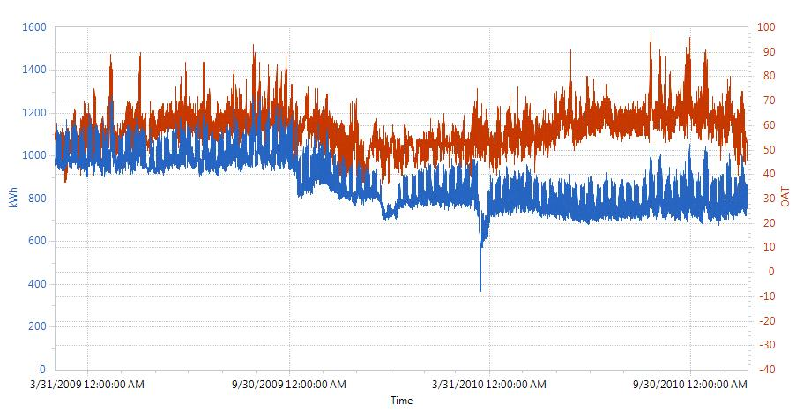
Installation Period (data not used)
Baseline Period
Post-Install Period

Figure 1b. View of Selected Baseline Period Data.
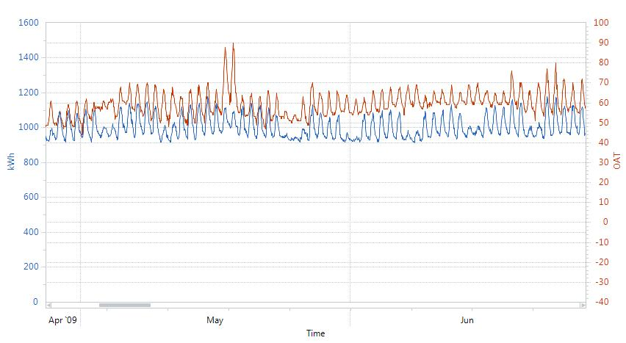

Figure 1c. View of Selected Post-Installation Period Data.
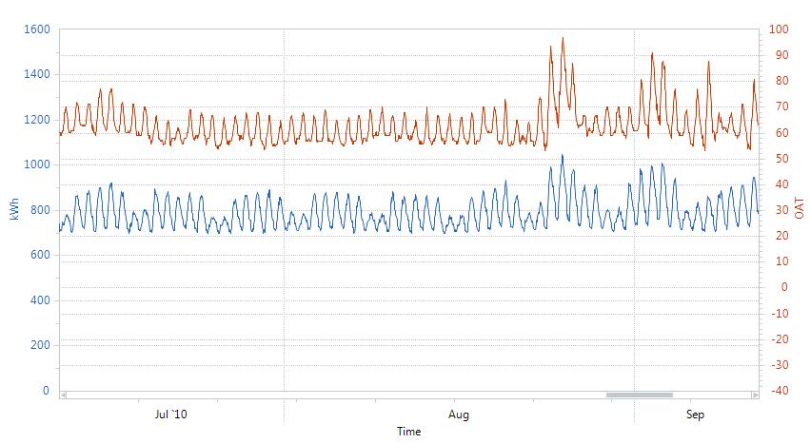

Develop Regression Models
- By examination of Figure 1, both baseline and post-installation period energy use appears to follow regular and predictable patterns. The building’s operation schedule was confirmed to follow a consistent schedule each week, and this is confirmed in the data. In addition, a significant dependency on ambient temperature (outside air temperature - OAT) is also evident in the data.
- A linear regression model using a time of week indicator variable, and a piecewise linear and continuous OAT dependence was chosen to model the hourly energy use for both the baseline and post-installation periods. This model is described mathematically in Appendix A.
- The selected model accounts for the different responses of energy use in different temperature regimes, for example, at low temperatures, electric energy use may increase as the building uses more pump and fan energy, at moderate temperatures, it may be insensitive to temperature, as the temperatures warm, the energy use increases due to the use of cooling systems, and so on.
- The model uses the time of week indicator variable to correct the building’s energy use response to temperature, for example, the energy use in the building when temperatures are 60 degrees °F at 9 am in the morning are much different than when it is 60 degrees F at 6 pm in the evening.
- This model form was programmed into an analysis module of free public domain software called the Universal Translator (UT). The software calculates some goodness-of-fit metrics and allows all dependent, independent, and predicted variables to be exported for analysis.

Baseline Model Development
- The hourly electric energy use data (in kWh) and ambient temperature (in °F) was imported into the UT M&V analysis module, and a linear regression model relating baseline energy use to time of week and temperature was developed using the modeling algorithm described above. A description of the data and model were output from the software:
  - Baseline period start date/time: 3/2/2009 12:00:00 AM
  - Baseline period end date/time: 10/2/2009 12:00:00 AM
  - R²: 0.88, CV(RMSE) = 2.31%
  - Number of data points: 5,135
  - Analysis time interval: Hourly
  - Independent variable: OAT
- Figure 2 shows a month of the baseline period hourly energy use data as well as the baseline model’s predictions.
- Next, the standard error of regression is determined. It was described in the introduction:
${SE}_{\hat{Y}}=\sqrt{\frac{\sum{{({\hat{Y}}_{i}-Y_{i})}^{2}}}{n-k-1}}$ (1)
- The standard error of regression was calculated by exporting the baseline period hourly measured (Y_{i}) and predicted values (Ŷ_{i}) of kWh into a spreadsheet and carrying out equation (1). For the baseline model, n = 5,135 points, k is the number of parameters in the regression equation, which has 168 coefficients for each hour of week parameter, and 6 temperature segments, each representing an additional parameter, plus one constant parameter: n – k - 1 = 5,135-168 - 6- 1 = 4,960. Using these values, SE_{Ŷ} = 23.8 kWh. This calculation and the first few rows of the spreadsheet are shown in Table 1.

Table 1. Baseline Model Analysis Spreadsheet.

  - The model residuals are examined to determine whether any patterns exist that indicate potential modeling errors. Figure 3 shows that the residuals do not exhibit a pattern and appear randomly spaced about the 0 axis. This indicates the independent variables and model form explain most of the variation in the energy use variable.
  - The time of week and temperature model is known to have autocorrelation, the degree of which can be evaluated with the Durbin-Watson test. The presence of autocorrelation means that confidence and prediction intervals estimated using the ordinary least squares approach may underestimate the actual intervals. This discussion is included in Appendix B.

Figure 2. Baseline Period Data and Model Predictions.
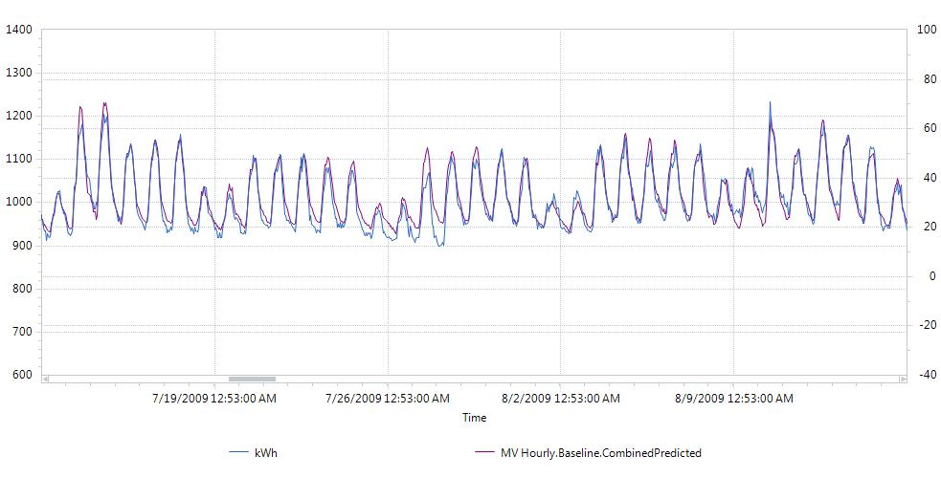
Figure 3. Baseline Model Residuals versus Predicted Values.

Post-Installation Model Development
- The same process was used to develop the post-installation energy use model as completed for the development of the baseline model. The description of the post-installation data and model were output from the software:
  - Post-Installation period start date/time: 5/15/2010 12:00:00 AM
  - Post-Installation period end date/time: 11/20/2010 12:00:00 AM
  - R²: 0.91, CV(RMSE) = 2.60%
  - Number of data points: 4,537
  - Analysis time interval: Hourly
  - Independent variable: OAT
- Figure 4 shows a month of the post-installation period hourly energy use data as well as the post-installation model’s predictions.
- The standard error of regression is determined.
  - The standard error of regression was calculated by exporting the post-installation period hourly measured (Y_{i}) and predicted values (Ŷ_{i}) of kWh into a spreadsheet and carrying out equation (1). For the post-installation model, n = 4,537 points, k = 174 as before. Using these values, SE_{Ŷ} = 21.0 kWh. This calculation and the first few rows of the spreadsheet are shown in Table 2.

Table 2. Post-Installation Model Analysis Spreadsheet.

  - The model residuals are shown in Figure 5, which shows that they do not exhibit a pattern and appear randomly spaced about the 0 axis.
  - As in the baseline case, the time of week and temperature model is known to have autocorrelation. A discussion on autocorrelation is included in Appendix B.

Figure 4. Post-Installation Period Data and Model Predictions.
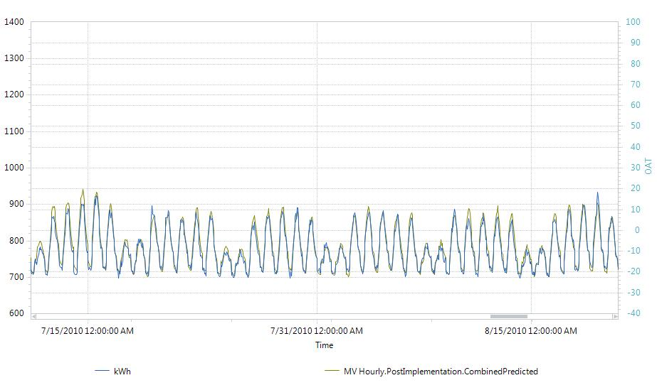
Figure 5. Post-Installation Model Residuals versus Predicted Values.

6. Savings and Uncertainty
- Non-routine adjustments, or adjustments to energy use based on unexpected increases or decreases in load were not detected in the building during the baseline or post-installation monitoring periods. The savings will be determined based only on routine adjustments in this example.

- Annual savings estimates were derived based on adjustments of baseline and post-installation energy use to typical meteorological year (TMY) weather conditions for this climate zone. The date and time, and OAT (dry-bulb) values for each hour in the TMY dataset were input into the UT software M&V analysis module. The adjusted baseline energy use, and adjusted post-installation energy use under TMY conditions was determined. Figure 6 shows the adjusted baseline energy use (purple), adjusted post-installation energy use (green), and TMY ambient temperatures (red).

Figure 6. Baseline and Post-Installation Energy Use under TMY Conditions
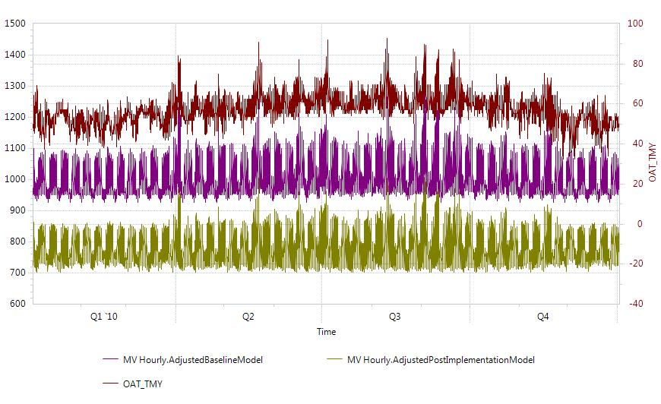

- The normalized savings is the difference between the adjusted (to TMY) baseline energy use and the adjusted (to TMY) post-installation energy use.

Savings = kWh_{adj-base} – kWh_{adj-post}
  - Where:
    - kWh_{adj-base} = annual baseline kWh under TMY conditions
    - kWh_{adj-post} = annual post-installation kWh under TMY conditions

  - These values were found after exporting the adjusted baseline and post-installation energy use to a spreadsheet and performing the calculations. Table 3 provides the first few rows of the data in a spreadsheet used to calculate savings and uncertainty. Savings = 8,824,822 – 6,866,654 = 1,958,168 kWh

- An estimation for the range of possible values for each prediction Ŷ in the baseline and post-installation periods can be computed using:
Where:
- Ŷ is the predicted value of energy from the regression model
- t is the value obtained from the t-tables, for 95% confidence, t = 1.96
- SE_{Ŷ} is the standard error of the estimate (prediction).

Table 3. First few rows of spreadsheet showing calculation of normalized savings and estimation of savings uncertainty.

- For the average baseline model prediction of energy use under TMY (or any) conditions, the 95% prediction interval is 1.96 × Standard Error of Regression (SE). The average baseline energy consumption associated with the prediction interval is the total baseline consumption divided by the number of hourly intervals: 8760. This means that the uncertainty in the adjusted baseline annual consumption is: $8760×\left(t×{SE}_{b}\right)$, or 8760 × 46.6 = 408,636 kWh, which is 4.6% of adjusted baseline annual consumption.

- Similarly, the uncertainty in the adjusted post-installation annual consumption is: $8760×\left(t×{SE}_{b}\right)$, or 8760 × 43.1 = 377,731 kWh, which is 5.5% of adjusted post-installation annual consumption.

- Once annual baseline and post-installation consumption have been estimated, the savings and savings uncertainty may be calculated. Savings uncertainty is calculated as the square root of the sum of the squared values of baseline and post-installation annual consumption. Savings Uncertainty = $\sqrt{{46.6}^{2}+{43.1}^{2}}$ = 556,475 kWh, which is 28.4% of the annual savings.

- Savings is fully stated as 1,958,168 ± 278,238 kWh at the 95% confidence level.

- This savings is well within the University’s uncertainty requirements.

Appendix A: Description of Time-of-Week and Temperature Model

- The following description is paraphrased from the Matthieu article, where a more comprehensive description may be found.
  - A facility’s electric energy use is a function of ambient temperature and time of week, so both are included in the model.
  - Each week is divided into hourly intervals (indexed by i), with the first interval from midnight to 1 am Monday morning, the second from 1 am to 2 am, and so on for the 168 hours each week. A different regression coefficient for each time of week indicator variable, α_{i} allows each time-of-week to have a different predicted load.
  - Energy response to temperature in a building is non-linear but may be modeled as continuous and piecewise linear. At low temperatures, electric energy use may increase due to more use of heating system equipment such as pumps and fans. In moderate temperatures, the building does not require heating and cooling and therefore energy use is not sensitive to temperature. At warm temperatures, energy use increases with increasing temperature due to use of cooling system equipment. At the highest temperatures, energy use may be again insensitive to temperature as cooling equipment has reached its maximum load. There may be multiple regimes of energy response to temperature.
  - The piecewise linear and continuous temperature at time t, T(t_{i}) (which occurs at time of week interval i) is broken down into a number of component temperatures, T_{c.j}(t_{i}), with j = 1 to n_{s} (n_{s} being the number of line segments, usually no more than 10 to avoid overfitting). Each T_{c.j}(t_{i}) is multiplied by β_{j} and then summed to determine the temperature dependent load.
  - Boundary values of the temperature segments are defined by B_{k} (k = 1…n_{s}-1). And component temperatures are determined with the following algorithm (assuming n_{s} = 6):
    - If T(t_{i}) > B₁, then T_{c,1}(t_{i}) = B₁. Otherwise, T_{c,1}(t_{i}) = T(t_{i}) and T_{c,m}(t_{i}) = 0 for m = 2 … 6 and algorithm is ended.
    - For n = 2 … 4, if T(t_{i}) > B_{n}, then T_{c,n}(t_{i}) = B_{n} – B_{n-1}. Otherwise, T_{c,n}(t_{i}) = T(t_{i}) – B_{n-1} and T_{c,m}(t_{i}) = 0 for m = (n + 1) … 6 and algorithm is ended.
    - If T(t_{i}) > B₅, then T_{c,5}(t_{i}) = B₅ – B₄ and T_{c,6}(t_{i}) = T(t_{i}) – B₅.
  - The building is anticipated to have a different response to temperature in occupied periods versus unoccupied periods. The occupied load is estimated using the following equation:
$${\hat{E}}_{o}\left(t_{i},T\left(t_{i}\right)\right)=α_{i}+\sum_{j=1}^{n}{β_{j}T_{c,j}(t_{i})}$$
- Unoccupied loads are expected to have a single temperature parameter, since the building is expected to operate without sensitivity to temperature at night. Unoccupied load is modeled with the following equation:

$${\hat{E}}_{u}\left(t_{i},T\left(t_{i}\right)\right)=α_{i}+β_{u}T(t_{i})$$

- The parameters α_{i}, for i = 1 to 168, β_{j} for j = 1 to n and β_{u} are estimated using the data from the baseline and post-installation periods with ordinary least squares.
- The model produces residuals that are autocorrelated and heteroscedastic, and the regression parameters α_{i} and β_{j} are correlated. This means that the standard errors associated with each regression parameter underestimates their level of uncertainty. However, uncertainty on the load predictions can be approximated with the standard error, which can be computed at each interval i.
- This algorithm has been programmed into a free public domain desktop software package. The software allows the user to input streams of date and time stamped energy use and ambient temperature data, manipulate parameters and develop linear regression models with time-of-week indicators and ambient temperature as independent variables.
- This algorithm has been programmed into an M&V analysis module of a free public domain desktop software package called Universal Translator. The software allows the user to input streams of date and time stamped energy use and ambient temperature data, manipulate parameters and develop linear regression models with time-of-week indicators and ambient temperature as independent variables. The software calculates the α_{i} and β_{j} parameters according to the user-specified analysis time interval (e.g. hourly or daily) and number of line segments for the piecewise continuous temperature dependence. Note that there are 168 coefficients for hourly time intervals, and 7 coefficients for daily time intervals, in addition to the specified number of line segments that make up all the terms in the resulting regression equation.
- The software does not export the final form of the energy models it develops, however it allows all analysis data to be exported. This data is analyzed to determine the goodness of fit and accuracy of the baseline and post-installation models prior to calculating

Appendix B: Model Autocorrelation and Cross Validation

- The Durbin-Watson statistic indicates the degree of autocorrelation. The statistic is calculated as:
$$d=\frac{\sum_{t=2}^{n}{{\left(e_{t}-e_{t-1}\right)}^{2}}}{\sum_{t=1}^{n}{e_{t}^{2}}}$$
  - Where:
    - e = Ŷ_{i} – Y_{i}, the residual at time i
    - n = number of data points
- If d is less than 1, significant autocorrelation exists in the data and uncertainties may be underestimated using standard errors calculated as described above. For the baseline model developed in the case study, d = 0.31.
- A cross-validation method was used to evaluate the prediction errors of the baseline model. Holding out one week of data for each month in the baseline period, the remaining data was used to develop a model. This model was used to predict the energy use during the held-out periods, and the prediction errors were determined by comparing model predictions with actual data. Figure B1 shows the held-out periods of data and Figure B2 provides a chart of the prediction errors of the held-out data. It is evident that Figure B2 shows a similar distribution of error as in Figure 3. The standard error calculated from the held-out data was 23.5 kWh, which is very close to the 23.8 kWh standard error estimated for the baseline model.

Figure B1. Baseline Held-Out Periods

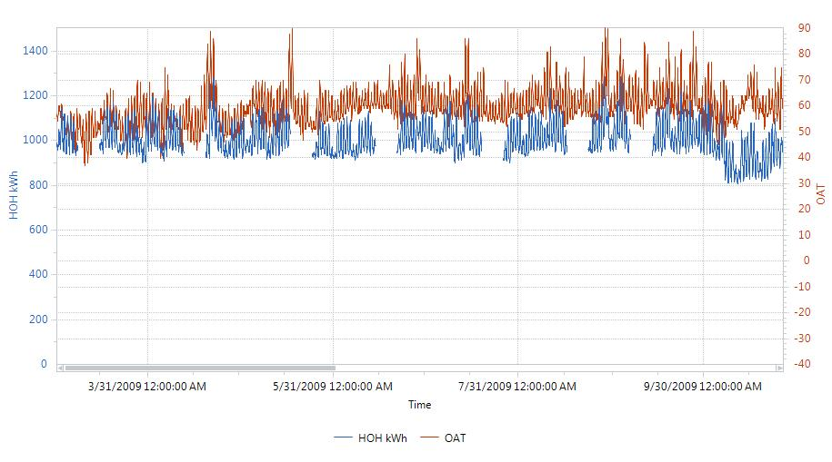
Figure B2. Distribution of Hold-Out Period Prediction Errors.

Appendix C: Analysis Using Daily Data

In this appendix, the same project and data were used, and the same procedures were followed, except that the data were re-sampled to daily time intervals before beginning analysis. Electric energy use data were summed over each 24 hour period of each day, and outside air temperatures (OAT) were averaged over the entire day. The daily data is shown in Figure C1. Note that other methods of re-sampling OAT data are possible and may improve model goodness-of-fit, however these methods were not used here.

Figure C1. Baseline through Post- Installation Electric Energy Use and Ambient Temperature Data
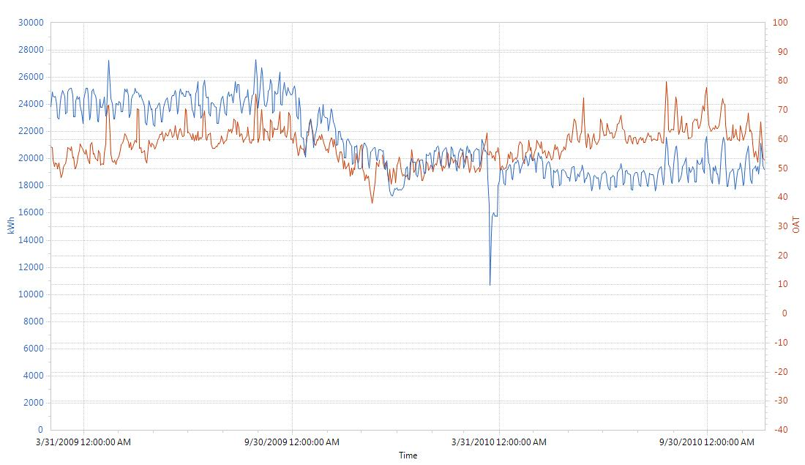
Post-Install Period
Installation Period (data not used)
Baseline Period

Baseline Model Development
- The daily electric energy use data (in kWh) and ambient temperature (in °F) was imported into the UT M&V analysis module, and a linear regression model relating baseline energy use to time of week and temperature was developed using the modeling algorithm described above. A description of the data and model were output from the software:
  - Baseline period start date/time: 3/2/2009 12:00:00 AM
  - Baseline period end date/time: 10/2/2009 12:00:00 AM
  - R²: 0.79, CV(RMSE) = 1.63%
  - Number of data points: 214
  - Analysis time interval: Daily
  - Independent variable: OAT
- Figure C2 shows the baseline period daily energy use data as well as the baseline model’s predictions.
- Next, the standard error of regression is determined:
${SE}_{\hat{Y}}=\sqrt{\frac{\sum{{({\hat{Y}}_{i}-Y_{i})}^{2}}}{n-k-1}}$ (C1)
- The standard error of regression was calculated by exporting the baseline period daily measured (Y_{i}) and predicted values (Ŷ_{i}) of kWh into a spreadsheet and carrying out equation (C1). For the baseline model, n = 214 points, k is the number of parameters in the regression equation, which has 7 coefficients for each day of week parameter, and 6 temperature segments, each representing an additional parameter, plus one constant parameter: n – k - 1 = 7 + 6 + 1 - 1 = 13. Using these values, SE_{Ŷ} = 408.4 kWh. This calculation and the first few rows of the spreadsheet are shown in Table C1.

Table C1. Baseline Model Analysis Spreadsheet.

  - The model residuals are examined to determine whether any patterns exist that indicate potential modeling errors. The residuals are plotted against the predicted values in Figure C3. Figure C3 shows that the residuals do not exhibit a pattern and appear randomly spaced about the 0 axis. This indicates the independent variables and model form explain most of the variation in the energy use variable.

Figure C2. Baseline Period Data and Model Predictions.
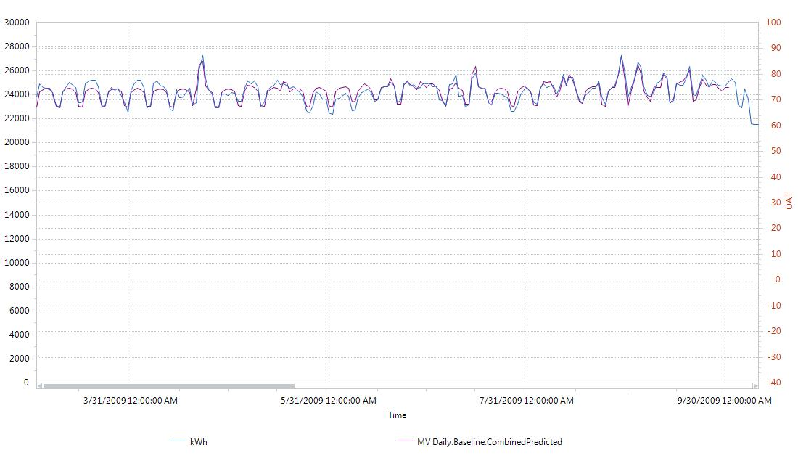

Figure C3. Baseline Model Residuals versus Predicted Values.

Post-Installation Model Development
- The same process was used to develop the post-installation energy use model as completed for the development of the baseline model. The description of the post-installation data and model were output from the software:
  - Post-Installation period start date/time: 5/15/2010 12:00:00 AM
  - Post-Installation period end date/time: 11/20/2010 12:00:00 AM
  - R²: 0.79, CV(RMSE) = 1.94%
  - Number of data points: 189
  - Analysis time interval: Daily
  - Independent variable: OAT
- Figure C4 shows the post-installation period daily energy use data as well as the post-installation model’s predictions.
- The standard error of regression is determined.
  - The standard error of regression was calculated by exporting the post-installation period hourly measured (Y_{i}) and predicted values (Ŷ_{i}) of kWh into a spreadsheet and carrying out equation (1). For the post-installation model, n = 189 points, k = 13 as before. Using these values, SE_{Ŷ} = 381.1 kWh. This calculation and the first few rows of the spreadsheet are shown in Table C2.

Table C2. Post-Installation Model Analysis Spreadsheet.

- The model residuals are shown in Figure C5, which shows that the residuals do not exhibit a pattern and appear randomly spaced about the 0 axis, indicating that the independent variables and model form explain most of the variation in the energy use variable.

Figure C4. Post-Installation Period Data and Model Predictions.
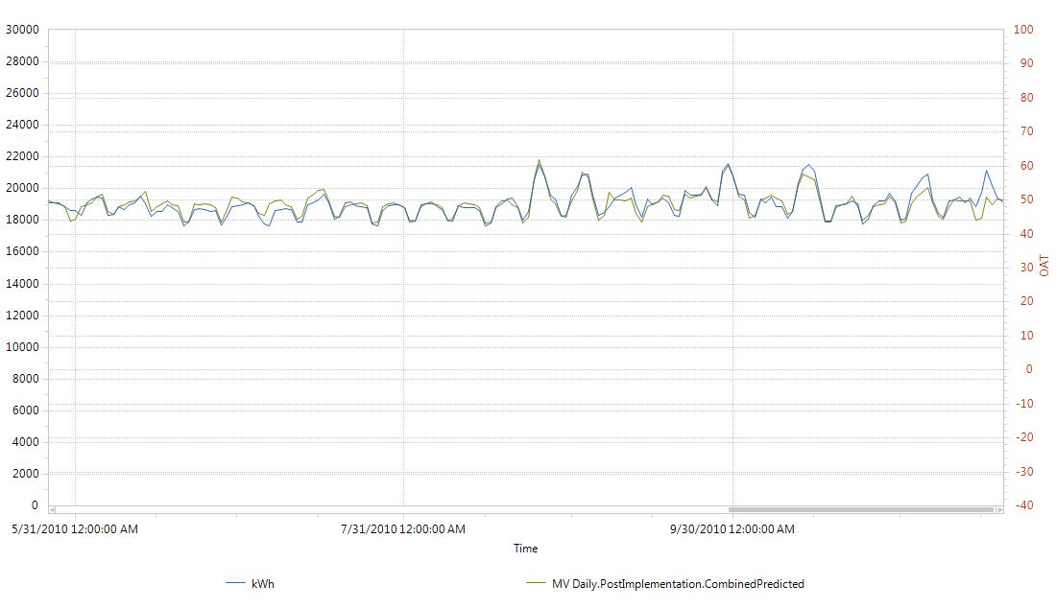
Figure C5. Post-Installation Model Residuals versus Predicted Values.

Savings and Uncertainty
- Annual savings estimates were derived based on adjustments of baseline and post-installation energy use to typical meteorological year (TMY) weather conditions for this climate zone. Outside air dry-bulb temperatures in the TMY data set were averaged over each day. The date and OAT (dry-bulb) values for each day in the re-sampled TMY dataset were input into the UT software M&V analysis module. The adjusted baseline energy use, and adjusted post-installation energy use under TMY conditions was determined. Figure C6 shows the adjusted baseline energy use (purple), adjusted post-installation energy use (green), and TMY ambient temperatures (red).

Figure C6. Baseline and Post-Installation Energy Use under TMY Conditions
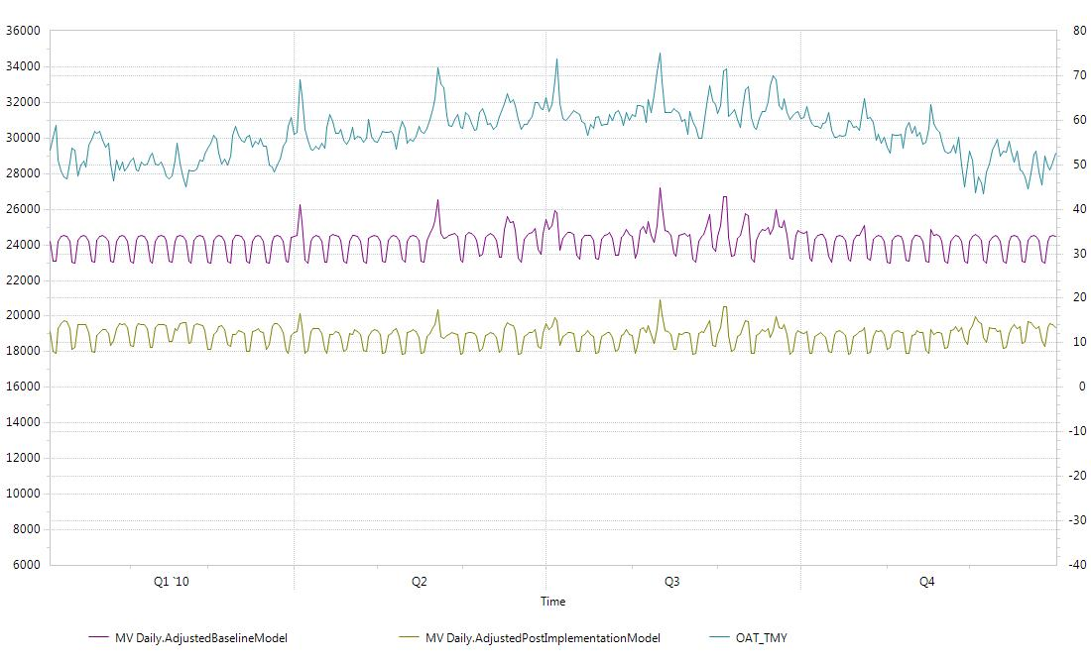

- The normalized savings is the difference between the adjusted (to TMY) baseline energy use and the adjusted (to TMY) post-installation energy use.

Savings = kWh_{adj-base} – kWh_{adj-post}
  - Where:
    - kWh_{adj-base} = annual baseline kWh under TMY conditions
    - kWh_{adj-post} = annual post-installation kWh under TMY conditions

  - These values were found after exporting the adjusted baseline and post-installation energy use to a spreadsheet and performing the calculations. Table C3 provides the first few rows of the data in a spreadsheet used to calculate savings and uncertainty. Savings = 8,810,432 – 6,890,776 = 1,919,656 kWh

- An estimation for the range of possible values for each prediction Ŷ in the baseline and post-installation periods can be computed using:
Where:
- Ŷ is the predicted value of energy from the regression model
- t is the value obtained from the t-tables, for 95% confidence, t = 1.96
- SE_{Ŷ} is the standard error of the estimate (prediction).

Table 3. First few rows of spreadsheet showing calculation of normalized savings and estimation of savings uncertainty.

- For the average baseline model prediction of energy use under TMY (or any) conditions, the 95% prediction interval is 1.96 × the Standard Error of Regression (SE). The average baseline energy consumption associated with the prediction interval is the total baseline consumption divided by the number of hourly intervals: 365. This means that the uncertainty in the adjusted baseline annual consumption is: $365×\left(t×{SE}_{b}\right)$, or 365 × 46.6 = 292,169 kWh, which is 3.3% of adjusted baseline annual consumption.

- Similarly, the uncertainty in the adjusted post-installation annual consumption is: $365×\left(t×{SE}_{b}\right)$, or 365 × 43.1 = 273,140 kWh, which is 4.0% of adjusted post-installation annual consumption.

- Once annual baseline and post-installation consumption have been estimated, the savings and savings uncertainty may be calculated. Savings uncertainty is calculated as the square root of the sum of the squared values of baseline and post-installation annual consumption. Savings Uncertainty = $\sqrt{{292,169}^{2}+{273,140}^{2}}$ = 399,960 kWh, which is 20.8% of the annual savings.

- Savings is fully stated as 1,919,656 ± 199,980 kWh at the 95% confidence level.

Matthieu, J.L., P.N. Price, S. Kiliccote, and M.A. Piette, “Quantifying Changes in Building Electricity Use, With Application to Demand Response,” IEEE Transactions on Smart Grid, 2:507-518, 2011
Mathieu, ibid.
M&V Analysis Module in PG&E’s Universal Translator version 3, available at www.utonline.org.
Matthieu, J.L., P.N. Price, S. Kiliccote, and M.A. Piette, “Quantifying Changes in Building Electricity Use, With Application to Demand Response,” IEEE Transactions on Smart Grid, 2:507-518, 2011
M&V Analysis Module in version 3 of Universal Translator. Available at www.utonline.org.
M&V Analysis Module in version 3 of Universal Translator. Available at www.utonline.org.

